- What are some Stopping Criteria for k-Means Clustering?
- What is the main difference between k-Means and k-Nearest Neighbours?
- Compare Hierarchical Clustering and k-Means Clustering
- Explain some cases where k-Means clustering fails to give good results
- How would you Pre-Process the data for k-Means?
- How would you perform k-Means on very large datasets?
- What is the difference between k-Means and k-Medians and when would you use one over another?
- How does the Curse of Dimensionality affect k-Means Clustering?
- How to determine k using the Silhouette Method?
- How does Forgy Initialization, Random Partition Initialization, and kmeans++ Initialization compare with each other?

- What are some Stopping Criteria for k-Means Clustering?
The common stopping conditions I have seen:
- Convergence. No further changes, points stay in the same cluster.
- The maximum number of iterations. When the maximum number of iterations has been reached, the algorithm will be stopped. This is done to limit the runtime of the algorithm.
- Variance did not improve by at least x
- Variance did not improve by at least x * initial variance
If you use MiniBatch k-means, it will not converge, so you need one of the other criteria. The usual one is the number of iterations.

2. What is the main difference between k-Means and k-Nearest Neighbours?
k-Means is a clustering algorithm that tries to partition a set of points into k sets such that the points in each cluster tend to be near each other. It is unsupervised because the points have no external classification.
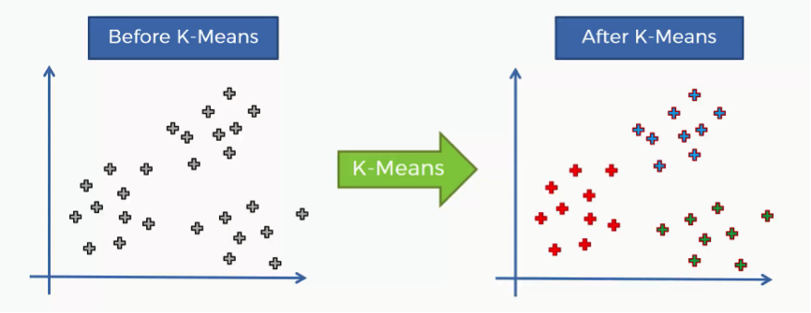
k-Nearest Neighbors is a classification (or regression) algorithm that, in order to determine the classification of a point, combines the classification of the k nearest points. It is supervised because it is trying to classify a point based on the known classification of other points.
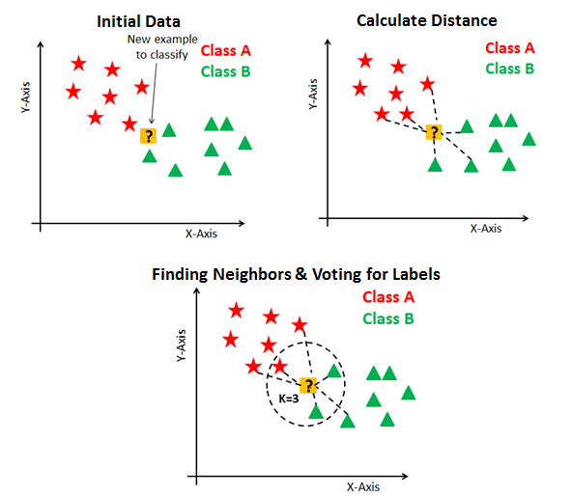

3. Compare Hierarchical Clustering and k-Means Clustering
Scalability
- k-means has an order of
- O(n.k.d.i)
- O(n.k.d.i). The scalability of k-means is better than hierarchical clustering because k, i, and d are small, and also the memory consumption is linear.
- Hierarchical clustering has an order of
- O(n^3d)
- O(n
- 3
- d). The scalability of hierarchical clustering is worse, and its memory consumption is quadratic.
Flexibility
k-means is extremely limited in applicability. It is limited to Euclidean distances, and it only works on numerical data.
Hierarchical clustering does not even require distances (any measure can be used, including similarity function simply by preferring high values to low values). It can use any type of data including categorical, strings, time series, or mixed.

4. Explain some cases where k-Means clustering fails to give good results
k-means has trouble clustering data where clusters are of various sizes and densities.
Outliers will cause the centroids to be dragged, or the outliers might get their own cluster instead of being ignored. Outliers should be clipped or removed before clustering.
If the number of dimensions increase, a distance-based similarity measure converges to a constant value between any given examples. Dimensions should be reduced before clustering them.

5. How would you Pre-Process the data for k-Means?
Some pre-processing steps to follow are:
If the variables are of incomparable units, then the variables should be standardized.
Even if the variables are of the same units but show quite different variances then it is a good idea to standardize them. Since k-means clustering produces more or less round clusters, it puts more weight on variables with smaller variance, so the clusters will tend to be separated along with variables with greater variance.
k-means clustering results are sensitive to the order of objects in the dataset, so it is good to randomize the dataset and try clustering many different times.

6. How would you perform k-Means on very large datasets?
- If the dataset is large, an alternative is using mini-batch k-Means.
- Mini batch k-means has the main advantage of reducing the computational cost of finding a partition. This cost is proportional to the size of the sample batch used and this difference is more evident when the number of clusters is larger.
- The main idea of mini-batch k-Means is to use small random batches of data of a fixed size, so they can be stored in memory. Each iteration a new random sample from the dataset is obtained and used to update the clusters and this is repeated until convergence.

7. What is the difference between k-Means and k-Medians and when would you use one over another?
- k-Means minimizes within-cluster variance, which equals squared Euclidean distances. In general, the arithmetic mean does this. It does not optimize distances but squared deviations from the mean.
- k-Medians minimizes absolute deviations, which equals Manhattan distance. In general, the per-axis median should do this. It is a good estimator for the mean if you want to minimize the sum of absolute deviations (that is sum_i abs(x_i-y_i)), instead of the squared ones.
To decide between k-means and k-medians, take into consideration the following:
- If the distance is squared Euclidean distance, use k-means.
- If the distance is Taxicab metric, use k-medians.
- If there is any other distance, use k-medoids.
There is an exception which is:
- Maximizing cosine similarity is related to minimizing the squared Euclidean distance on the L2-normalized data. So, if the data is L2 normalized, and it is L2-normalized each iteration, then k-means can be used.

8. How does the Curse of Dimensionality affect k-Means Clustering?
- k-Means is a search strategy to minimize the squared Euclidean distance.
- As the number of dimensions increase, the objects become approximately equidistant (at equal distances) from each other given that the data is distributed uniformly throughout the space.
- What matters is not necessarily the number of variables, but the effective dimensionality of the data. It is quite common that most of the variation exists in a couple of dimensions. If this is the case then there will be fewer problems with k-means in the sense that the effective dimensionality is much smaller.
- Therefore, under the assumption that there are meaningful latent groupings in the data, they do not necessarily exist in all of the dimensions or in constructed dimensions that maximize variation. The clusters might be in the lower-variation dimensions.

9. How to determine k using the Silhouette Method?

The Silhouette Value measures how similar a point is to its own cluster (cohesion) compared to other clusters (separation).
The range of the Silhouette value is between +1 and -1. A high value is desirable and indicates that the point is placed in the correct cluster. If many points have a negative Silhouette value, it may indicate that we have created too many or too few clusters.
We now define a silhouette (value) of one data point
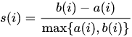
And
if
The Silhouette Score reaches its global maximum at the optimal k. This should ideally appear as a peak in the Silhouette Value-versus-k plot.
Here is the example plot:
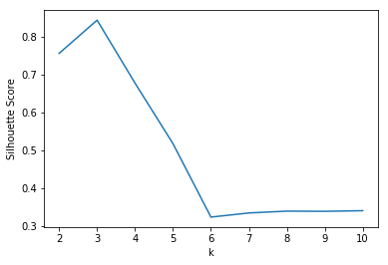
10. How does Forgy Initialization, Random Partition Initialization, and kmeans++ Initialization compare with each other?

The results of k-Means depend heavily on the initialization:
- Forgy Initialization: In this method, the algorithm chooses any k-points from the data at random as the initial points. This method makes sense because the clusters detected through the k-means are more probable to be near the modes present in the data. This method is one of the faster initialization methods for k-Means. If we choose to have k clusters, the Forgy method chooses any k points from the data at random as the initial points.
- Random Partition Method: In this method, each point is randomly assigned in the data to a random cluster-ID. Then the cluster IDs are grouped, and their average is taken to yield the initial points. This method yields initial points which are closer to the mean of the data. k-Means is more likely to get stuck in Local Optima if initialized using this method.
- kmeans++: In this method, one random point is chosen from the dataset. Then another point is chosen such that it is more probable to lie at a large distance from the first point. The remaining points are generated by a probability distribution that is proportional to the squared distance of each point from its closest center.
Usually, the initialization method which gives the best result is the kmeans++.

